Name __________________________________________________________________ Period _________

PLATE TECTONICS
The Earth’s crustal layer is broken into large moving sections of lithosphere (the crust and the very top of the mantle) called plates. Most plates are made of both oceanic and continental crust, but some, like the Pacific Plate contain only oceanic crust. Most of the world’s volcanoes and earthquakes occur along the boundaries of these plates as they move apart, bump into each other, or push past each other.

Directions: Color oceanic crust dark brown, and continental crust light brown. Color the magma red and the motion arrows green. In the box below the diagram draw in two convection currents moving in the correct directions, color them red or orange.
Divergent Boundary (Pulling Apart Movement): Two plates are moving away from each other and new oceanic crust forms as molten rock rises up from inside the Earth. Over the past 165 million years, this sea-floor spreading has produced the Atlantic Ocean.
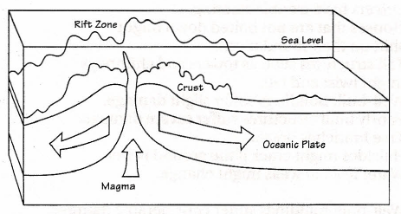

Geologic Feature (2) ______________________________________________________
_______________________________________________________
Convergent Boundary (Collision or Subduction Movement): When two plates move into each other, one of two things will occur:
- One plate is forced down under the other. This movement, called subduction, occurs when a heavier oceanic plate meets a lighter continental plate, or when two oceanic plates converge. As the heavier plate is subducted (pushed under) it melts, creating pockets of magma.
- The plates collide and fold up against each other. This happens when the continental part of plates converge. Mountain ranges such as the Himalayas, were formed this way.
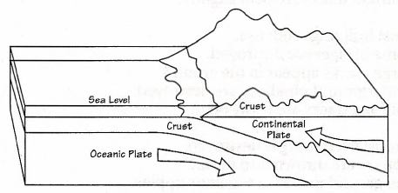
Melted crust (Magma)
This collision has produced a Subduction zone.

Geologic Feature ________________________________________________________

Transform Boundary (Lateral Movement): Two plates move past each other along faults in what is called a slip-stick motion. The San Adnreas fault in California is an example of lateral movement between the Pacific Plate and the North American Plate
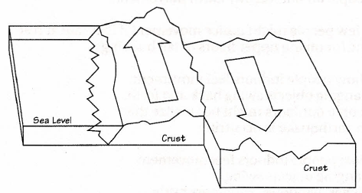
No convection currents to draw,

Type of boundary: ____________________________________________________

